The One With All The Kissing

Written by: Wil Calhoun
Transcribed by: Eric Aasen
502 来吻别吧
莫妮卡和钱德继续地下情: 乔伊闯进浴室，莫妮卡躲到浴缸内泡沫里；
一次，钱德无意中当众和莫妮卡吻别，为掩人耳目，他不得不和所有的女孩依次吻别。
菲比为错过伦敦好戏而苦恼；
大家起初想带她到中央公园野餐散心，后来决定同去亚特兰大度周末；
出发前，菲比破水了。
瑞秋自希腊飞回，为最近的头脑发昏而懊丧不已，她向莫妮卡发表爱情宣言。瑞秋想跟罗斯表白，莫妮卡坚决反对。
罗斯计划送浪漫礼物给艾米丽，挽回芳心。
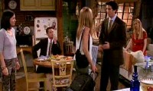
5.02 The One With All The Kissing
Monica and Chandler try to keep their relationship hidden: When Joey comes into the bathroom, Monica has to duck(v.没入水中) under the bubbles in the tub;
Chandler accidentally kisses Monica good-bye in front of the others, so then has to kiss all the girls.
Phoebe is irked(v.厌倦 苦恼) by all the fun she missed in London;
the others decide to take her on a picnic to Central Park, but since that idea sucks they plan a weekend in Atlantic City;
just as they're leaving, her water breaks.
Rachel, back from Greece and angry about the bad choices she's made recently, gives decision making control of her love-life to Monica.
This arrangement is strained (adj.拉伸的 勉强的 牵强附会的)to the breaking point(n.转化点 强度极限破损点 断点) when Rachel wants to tell Ross she still loves him, but Monica won't let her.
Ross plans to win back Emily by sending romantic gifts.
[Scene: Chandler and Joey's Bathroom, Chandler and Monica are sharing a candlelight bubble bath while drinking champagne and they clink their glasses.]
candlelight n.烛光/bubble bath<美>泡泡浴 泡沫剂/clink glasses v.碰杯
bubble bath

Monica: You look cute in bubbles.
Chandler: Ehh, you're just liquored up.
liquor up vi.狂饮(喝大量的酒)
(They move into kiss but are interrupted by Joey knocking on the door.)
Joey: Hey, it's me! I'm comin' in!
(Monica quickly dives under the water as Joey enters. He looks a little shocked at what Chandler's doing.)
Chandler: I've had a very long, hard day.You're home early.
Joey: Yeah, my date threw up.
throw up v.呕吐
Joey: Ahh, I'm gonna go get some chicken. Want some?
Chandler: Ahh, no thanks. No chicken, bye-bye then.
Joey: Okay.
(Joey turns to leave but stops at the door.)
Joey: You sure? Some extra-crispy? Dirty rice? Beans?
extra-crispy adj.特脆的/
Dirty rice ：is a traditional Cajun(n.移居美国路易斯安纳州的法人后裔) dish made from white rice cooked with small pieces of chicken liver(n.鸡肝) or giblets(n.残余物), which give it a dark ("dirty") color. The cooked livers tend to be dry, but carry a very mild(adj.淡味的) flavor. Similar to a pilaf[n.肉饭(由大米加鱼或肉及调料煮成)], it also includes green bellpepper, celery(n.芹菜) and onion (the "holy trinity"). Parsley(n.欧芹) and/or chopped green onions are common garnishes(n.装饰食物). Dirty rice is most common in the Cajun regions of southern Louisiana and Mississippi, however it can also be found in other areas of the American south.
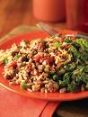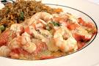
Chandler: For the last time no! Get out! Get out, Joey!
Joey: All right!
(Joey leaves and Monica comes up for air.)
Chandler: Are you okay? I'm so sorry, he wouldn't leave. He kept asking me if I want chicken.
Monica: Chicken? I could eat some chicken.
Chandler: Hey Joe!
(Monica goes back underwater as Joey re-enters.)
Chandler: Yeah, can I get a 3-piece, some coleslaw, some beans, and a Coke-(Yelps in pain as Monica grabs him underwater)Diet Coke.
cole n.油菜 小菜/slaw n.卷心菜色拉/yelp vi.(狗)吠 (因痛而)叫喊
coleslaw (or cole slaw)：is a salad consisting primarily and minimally(adv.最低程度地) of shredded(adj.切碎的), raw, white cabbage(n.卷心菜), although it often also includes shredded carrots.凉拌卷心菜
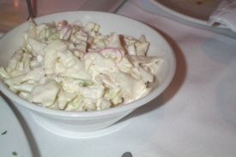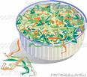
(Joey gives him a thumbs up and heads for the chicken.)
Opening Credits
[Scene: Monica and Rachel's, Chandler, Joey, and Monica are eating breakfast.]
Phoebe: (entering) Hey!
Chandler: Hey, Pheebs!
Joey: Mornin' Pheebs!
Phoebe: I have to tell you this story. Okay, I was coming over here and this driver…
Joey: (interrupting) Was his name Angus? (Monica and Chandler laugh.)
Phoebe: What?
Joey: Oh, he was this cab driver we had in London.
cab driver n.出租车司机
Phoebe: Oh. Ha-ha-ha. All right, anyway…
Monica: Wait, what that place, that pub he took us to?
Chandler: Uh, The Wheatsheaf.
Joey: Yeah-yeah-yeah, and they had that beer! That uh…
Monica: Bodington's!
Bodington：这是一种英国啤酒品牌，莫尼卡、钱德勒和乔伊大谈伦敦奇遇时聊到了这种酒，让菲比感到有点受冷落。据说这也是罗大佑喜欢的啤酒。

All: Bodington's! Woohoo! (And they all high-five each other.)
Chandler: Ooh! Ahh, Pheebs, was gonna tell a story.
Phoebe: Yeah, so, he had a really funny hat—I don't want to talk about it.
Ross: (entering) Hey!
All: Hey!
Joey: Hey, Ross, Bodington's!
Ross: Yeah! (They high-five.)
Joey: That was good beer.
Ross: Ohh…
Joey: Y'know, I'd walk back to London for another frosty one of those bad boys.
frosty <俚>An alcoholic beverage
Ross: Y'know, I think they have those at that British pub near the trade center.
Trade Center n.市贸中心
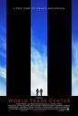
Joey: Later回头见! (Exits.)
Ross: Isn't Rachel supposed to be back by now?
Monica: Yeah, but her plane got delayed in Athens. But actually, (Checks watch) she should be here by now.
by now adv. 到如今 至此
Ross: Oh, so-so you talked to her. Did she, did she sound mad?
Monica: No, but she likes me. You abandoned her on a plane to Greece.
Ross: Okay, I did not abandon Rachel! Okay? Emily showed up at the airport! I had to go after her! I mean, I-I did what I had to do! She's my wife! Rachel is my wife! Y'know—Emily! Emily, is my wife! Man, what is that?
Phoebe: So you still hadn't heard from Emily?
Ross: No, not since I lost her at the airport.
Chandler: I can't believe she can outrun you man!
outrun vt. 超过范围 追赶 比...跑得更快
Ross: HEY, SHE'S FAST!! OKAY?!! (Chandler is so shocked at Ross's outburst that he drops his spoon and backs up) Oh! You-you think you can be beat me? Let's go! Outside!! I'm sorry. I'm just a little…
outburst n.(火山 感情等)爆发
Monica: Slow?
Ross: Oh, you want some?! Okay, get the shoes on! Let's go, man!
Monica: It's cool, okay? You're the fastest!
Rachel: (entering) Hi!
All: Hey! (They all go hug her, except for Ross.)
Ross: Rach, Rach, I am so sorry. I am so-so sorry.
Rachel: Oh Ross, come on! You just did what you had to do.
Ross: That's it? You're not mad? I mean, it must've been terrible.
Rachel: Terrible? Hell, I was in Greece! That was a nice hotel! Nice beach, met the nice people. Not too shabby for Rachel. (Goes and puts her luggage away.)
shabby adj.不体面的 寒酸的 低劣的
Ross: So, what? That's it?
Rachel: Well, yeah! We're cool. Totally cool.
Ross: Oh, thanks. Oh, you're the best. (They hug.)
Rachel: Oh no, you're the best.
Ross: (breaking the hug) Ohh, I gotta go to the flower store! (Runs to the door.) Check it out, no one will tell me where Emily is, so I'm gonna send 72 long-stem, red roses to Emily's parent's house, one for each day that I've known and loved her. That oughta get her talking to me again.
long-stem adj.长茎的
Chandler: Oh, Ross, when you make out card; be sure to make it out to, EM-I-LY.
make out card v.填写卡片
(Ross bangs his fists together to tell Chandler off, like what was learned last season. Read about it here.)
tell off v.责备
Monica: Rach, that's great! It's so good that you had a good time in Greece!
Rachel: What?! I didn't have a good time in Greece! Ross abandoned me! Okay, I couldn't get a plane out, so I had to stay in their honeymoon suite with people coming up to me all the time going, "Oh, Mrs. Geller, why are you crying?" I mean, it was sooo humiliating. I felt like such an idiot! I mean, it's all my fault! And you know why, because I make very bad decisions.
humiliating adj.丢人现眼的 羞辱性的
Chandler: Oh that's not true.
Rachel: Yes it is! It is true! I went, I went after Ross in stupid London.
Phoebe: London is stupid! Stupid!
Rachel: I put on a cheerleading outfit to seduce Joshua. Then I lost him because I asked him to marry me after four dates. And then I went to Greece on somebody eIse's honeymoon. Okay? Do those sound Iike very good decisions to you?
Monica: I like your Iittle braid.
braid n.发辫 辫子 辫带

Rachel: You know what? I just shouldn't be allowed to make decisions anymore.Phoebe, you were right. I should've never gone to London, and from now on you make all of my decisions for me.
Phoebe: Oh… No, I did that for someone once and I'm not comfortable having that kind of power and control over someone's life.
Monica: I'll do it!
Rachel: That's fine. So Monica, you are now in charge of my love life.
Chandler: Okay, I gotta go to work.
(He gets up and gives Monica a rather passionate kiss as Rachel and Phoebe look on in amazement. After the kiss ends, Chandler suddenly realizes what he just did, so he decides to do something rather rash.)
look on v.旁观/rash adj.轻率的 匆忙的 卤莽的
Chandler: And uh, Rachel, glad to have you back.
(He goes over and gives Rachel the same treatment he gave Monica, only Rachel is shocked.)
Chandler: Pheebs! (He goes over and kisses Phoebe, who is also stunned.) Always a pleasure. (And he struts out leaving the girls to stare at each other.)
strut vi.大摇大摆地走
[Scene: Central Perk, Monica, Rachel, Chandler and Joey are there looking at pictures from the trip to London.]
picture n.照片
Monica: Oh, Rachel, sweetie, look, here's a really cute picture of Joey and you at the reception.
Rachel: Ohh, he's married! Ross is married. I can't—I still can't believe it. (Rachel grabs the picture from Monica)
Monica: Honey, sweetie, by the edges.
by the edges拿照片的边缘
Rachel: I mean, y'know I'm just gonna have to accept it (She grabs the rest of the pictures)…
Monica: Ohh. (Monica covers her eyes in horror.)
Rachel: …I mean it's my fault.
Monica: Sweetie! Edges! Fingers! Smudgy! Pictures!
smudge n.污点 渍痕/smudgy adj.脏污的 满是污垢的
Rachel: Oh my God! (She licks the top picture and hands them back.)
Monica: Okay. That's okay. I-I know that you're very upset right now. I know, I know that wasn't about me不是和我作对.
Joey: (To Chandler) I bet it was about her a little.
Monica: If you would stop thinking about Ross for one minute you would notice that there are great guys everywhere! I mean, look! Look, Gunther! (Gunther turns to listen in.) I mean, he's nice, he's cute.
Rachel: Yeah, I guess Gunther is kinda…
Monica: (Interrupting) Oh, what about that guy over there? (She points at another guy and Gunther is deflated.) Remember? That is the guy you flirted with at the counter that time.
deflated a.(球 轮胎等)泄气的
Rachel: Oh, I don't know. I don't know.
Monica: You're going to talk to him! Y'know what? We made a deal, I make your decisions and I say you're going to talk to him.
Rachel: All right, you're the boss. I guess I gotta do what you tell me.
Joey: Say that to him and you're golden. (She just glares at him.)
golden <俚>Complete, good to go, alright 有出息的
Phoebe: (entering) Hey!
Rachel: Hey!
Joey: Hey, Pheebs!
Monica: We got out pictures back from London. (Shows her one.) Here's all of us at the Tower of London.
Tower of London：Her Majesty's Royal Palace and Fortress The Tower of London, more commonly known as the Tower of London (and historically simply as The Tower), is a historic monument in central London, England on the north bank of the River Thames. It is located within the London Borough(区 自治的市镇) of Tower Hamlets and is separated from the eastern edge of the City of London by the open space known as Tower Hill.伦敦塔

Phoebe: (Grabs the pictures) Oh! Here we all are! Yeah, there's Ross and Joey and you and me. (She picks up a magic marker and draws herself in. Monica can't watch.)
magic marker:Marker pen, or marker, is a term used to refer to various kinds of pens which have their own ink-source and usually a tip made of some porous(adj.多孔渗水的) material. When the tip is made of felt it can be called a felt-tipped pen. However, see dialectal variations, below. A temporary marker uses an erasable ink - an ink that adheres to the writing surface without binding(n.粘连) or being absorbed. Such non-permanent markers are intended for use on overhead projectors(n.投影仪), whiteboards, or for use by children when adults want to be able to clean up after them 魔术马克笔
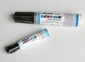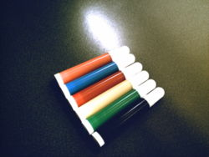
Chandler: All right, y'know what, we've been talking about London too much haven't we?
Phoebe: No. I'm sorry. It's just 'cause I couldn't be there. 'Cause all I ever get to do now is pregnant stuff, it just bums me out.
bum sb out 令某人觉得很厌烦
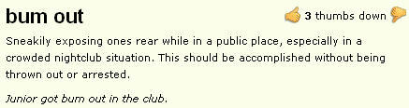
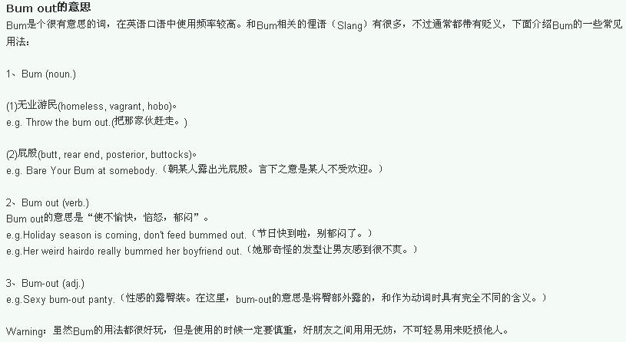
All: Sorry.
Monica: You know what I Iike to do? It sounds a little corny,but sometimes when I'm bummed out, I Iike to just close my eyes and think about what a wonderful gift life is. See?
corny：dull and tiresome but with pretensions of significance or originality adj.平淡无奇的 乡巴佬的<俚> (adj) really stupid, or using ironic situations.
(Rachel returns.)
Monica: What happened?
Rachel: Well, y'know, a little of this, a little of that. Got myself a date tomorrow night.
Monica: See, didn't I tell you?! You're getting over Ross already!
Rachel: Well…
(Gunther goes up to the guy and holds a sign that reads, "We reserve the right to refuse service to anyone.")
Gunther: (To the guy) Get out!
[Scene: Monica and Rachel's, Chandler enters to find Monica waiting patiently for him. He closes the door and they start kissing.]
Monica: What took you so long?
Chandler: I got caught up and work, but I'm quitting tomorrow.
Monica: Oh, good.
(They start kissing and turn around so that Chandler is facing the door. And Chandler sees Rachel, Phoebe, and Joey walk in and quickly ends the kiss with Monica.)
Chandler: So, thanks for having me over! Rach. (Goes over, grabs her, and kisses her.) Pheebs. (After a moment while he decides how to kiss her around her belly, grabs her and kisses her.)
Joey: (Jumping out of his way) See ya!! (To the girls.) What the hell was that?!
Monica: Probably some y'know, European good-bye thing he picked up in London.
Rachel: That's not European!
Phoebe: Well, it felt French.
(Joey is intrigued.)
intrigued adj.好奇的 被迷住了的
Joey: Well, I guess it's time for me to say goodbye too, mon frère,Come here and give me a little sugar.
[Scene: The hallway between the apartments, Rachel is returning from her date with Dave.]
Rachel: Oh God, I really had a good time!
Dave: Yeah, me too. (They reach her door.) So, I guess this is it.
Rachel: Yeah. Umm, unless you wanna come inside?
Dave: Yeah!
Rachel: Okay. Oh, uh, wait a minute, y'know what? I uh, I can't decide this. Umm, okay, just hold on a second.
Dave: Okay, yeah!
(She enters the apartment, leaving Dave in the hallway, to find Ross sitting on the couch with a big box.)
Rachel: Umm, hi!
Ross: Hi.
Rachel: Is Monica around? I-I have to ask her something.
Ross: She's doing her laundry.
Rachel: What's that? (Points to the box.)
Ross: It came in the mail today, it's uh, 72 long-stemmed red roses, one for each day that I've known and loved Emily, cut up into mulch!
cut up v.切碎/mulch n.护盖物 护根层 根篱

mulch
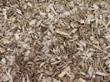
Rachel: Oh, honey that's awful.
Ross: Oh, it's not so bad. Monica's gonna make potpourri! I think I'm gonna go wander out in the rain for a while.
potpourri n.<法>混合香料 百花香(指放在罐内的干燥花瓣和香料混合物,能散发香味)
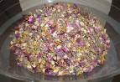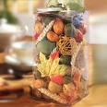
Rachel: But, it's not raining.
Ross: I can't catch a break!
catch a break 赌一把 碰运气/break <口>机会 好运
Rachel: Y'know what Ross? You're not going anywhere. You're gonna sit right here. I'm gonna make you a cup of tea and we're gonna talk this thing whole out. All right? (She goes out to talk to Dave) Hey, Dave!
talk out v.谈个明白 详尽讨论 说明
Dave: Yeah?
Rachel: Umm, listen, I'm gonna need to take a rain check, my roommate is just really sick. Okay? Bye! (She goes back in to talk to Ross.) Honey, listen, I know, I know things seem so bad right now.
Rain check是美国流行口语，典故出自露天举行的棒球比赛。棒球是最受美国人欢迎的运动之一。如球赛进行时天不作美，突然之间下起了倾盆大雨，比赛不得不取消，但是观众可以领取“雨票”，或用原票存根作为“雨票”(rain check)，即球赛改期举行时可凭之入场。Rain check这句话后来有了引伸意思，日常生活中普遍应用。 比方说有人请你吃饭或看戏，假如你刚巧因事不能奉陪，你可用婉谢的口吻说：May I take a rain check？ 直解是：可以给我一张雨票吗？ 地道英语的引伸义是：这次抱歉不能赴约，下次再约吧。Rain check 这个词也可以用在社交场合。假如一个男学生要请一个女孩子去吃晚饭，可是这女孩当天已经有了约会。不过她很喜欢这个人，很想跟他出去玩。这时候，她就说： "I'd love to go out with you, Ben. I'm sorry I'm busy tonight, but I'd like a rain check."她说：“我很愿意和你出去玩。但是，非常抱歉的是我今晚很忙。我们下回去玩好吗？”上句是很客气的委婉讲法。如果约你的外国朋友已经是很熟的了，你大可直接说 I'll take a rain check。
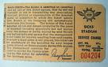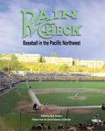
Monica: (Poking her head in) Rach? Can I talk to for just a minute? I-I dropped some socks.
poke sb's head in v.把头探入
Rachel: Yeah. (She goes out to join her in the hall and starts looking for the dropped socks.)
Monica: What is the matter with you?! Do you want to fall into the trap? Do you want to fall into the trap?!
Rachel: Ohh! You did not drop any socks!
Monica: I just ran into Dave and he told me that you blew him off! I mean, you listen to me! Now, I'm calling the shots! I say you leave Ross alone and go get Dave! What the hell were you trying to do?
run into v.撞见/blow sb off v.打发某人走/call the shots v.定调子 操纵
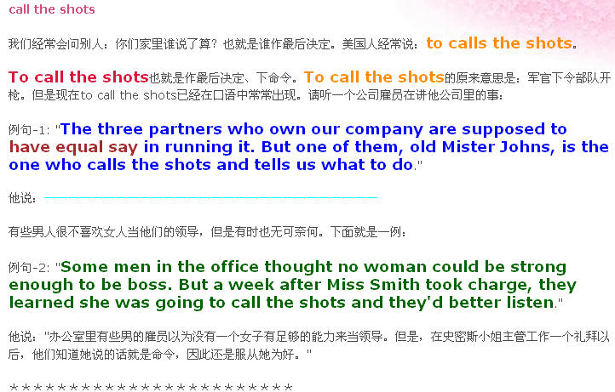
Rachel: Well, ultimately, I was trying y'know, I-I wanted…tell him y'know, that I'm still in love with him.
ultimately adv.最后 终极地
Monica: (Gasps) What?!! You cannot tell him that!!
Rachel: Why? Why not?! People love to hear that! Come on, I Iove you. Wasn't that nice?
Monica: No.I make the decisions, and I say no.
Rachel: Well, y'know what, no, you do not make my decisions because y'know what, you're fired.
Monica: You can't fire me. I make your decisions and I say, "I'm not fired!" Ha!
Rachel: Well… (At a loss for words, she grabs some of Monica's laundry and throws it on the floor as a diversion to allow Rachel to run back inside and close the door. Monica chases her to find that Rachel had locked the door.)
at a loss for words 哑口无言 一时找不出说什么话/diversion n.分散注意力的东西
Monica: Rachel!! Come on! Let me in!
Joey: (Poking his head out.) Havin' some trouble?
Monica: Rachel locked the door.
Joey: I'll kick that door in if you give me a little sugar.
Rachel: Ross, there's something I wanna talk to you about. I just need to…
Monica: Rachel, open this door!
Ross: What, is it locked?
Rachel: She's fine. Listen....
Monica: Rachel, I can do this all night if I have to!
Ross: You want me to get that?
Rachel: No. Just Iet her do her thing and we'll do our thing. Because I really need to tell you…
Monica: Thank you.

Commercial Break
[Cut to inside the apartment, Ross decides to let Monica in and goes over and opens the door in mid-pound.]
pound n.重击
Monica: Rachel, can I talk to you outside for a sec?
Rachel: No.
Monica: I really need to talk to you.
Rachel: Well, then talk!
Monica: Okay, I will. Remember that thing that we just discussed that you wanted to do?
Rachel: Yes!
Ross: What thing?
Monica: Well, Rachel wants to take swing dance lessons. Which I think is a really stupid idea! It's dangerous, she's never gonna get what she wants, and who knows who she might (Turns to look at Ross) end up hurting.
Swing Dance：瑞秋坚持要把自己仍然爱罗斯的感觉告诉罗斯，但莫尼卡竭力阻止。在罗斯出现的情况下，她发明了一套隐喻来说服瑞秋，她把瑞秋的想法叫做准备参加“摇摆舞蹈(swing dance)班”，结果罗斯也告诉他“摇摆舞蹈”比较危险。摇摆舞是一种身体有摇摆动作的舞蹈，事实上现在很多现代舞都有摇摆动作。

Ross: Monica's right, swing dancing can be tricky. I'm gonna use the phone. I gotta cancel those five giant teddy bears I sent to Emily. (Looks at the rose mulch.) My God, think of the massacre.
tricky adj.微妙的 难处理的 棘手的/massacre n.残杀 大屠杀
giant teddy bears
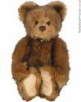
Rachel: I'm gonna do it.
Monica: All right, Rachel, I know-I know you think I'm crazy, please, before you tell him you love him, just-just try to find one person who thinks this is a good idea. Because I bet you, you can't.
Rachel: But I…
Monica: Please!
Rachel: All right, fine.
(There's a loud bang on the door.)
Monica: Joey, I'm in!
Joey: (In tremendous pain) All right. Good deal.
good deal <俚>awesome cool
[Scene: Central Perk, Joey, Chandler, Monica are there as Rachel enters.]
Rachel: Hi.
ALL：Hey, Rach.
Monica: Did you find anyone who agrees with you?
Rachel: No. But you know what? I think I need a male point of view. Joey,you're a man.
point of view n.观点
Joey: You got that right.
Rachel: Do you think it would be a good idea if I told Ross that I was still in love with him?
Joey: Nope.
All: Pheebs! Hey Pheebs!
Joey: Uh, okay, Pheebs?
Phoebe: Yeah?
Joey: Umm, y'know how the other day you were talking about how you didn't get to go to London and how you were kinda feeling left out?
the other day adv.前几天/be left out v.被抛弃 被遗弃
Phoebe: Yeah?
Joey: All right, well, we felt really bad about that so we decided we should all take a little trip together!
Phoebe: Ohh, that's so nice! How great! Well, where? Where's the trip?!
Monica: Well, we thought we would all go to a picnic (Phoebe gasps), in Central Park!
central park：纽约中央公园.南起59街，北抵110街，东西两侧被著名的第五大道和中央公园西大道所围合，中央公园名副其实地坐落在纽约曼哈顿的中央。340公顷的宏大面积使她与自由女神、帝国大厦等同为纽约乃至美国的象征。
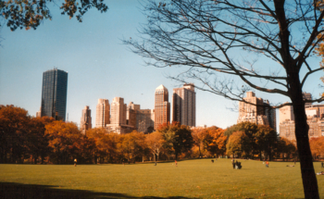
Phoebe: (excited) Central…(not so excited) Park!
Joey: Yeah, all of us! All day!
Phoebe: That sucks! That's not a trip! I just came from the park! What are we gonna high-five about at the stupid Central Park? "Well, it's right by my house, all right!"
Chandler: Well, I'm gonna go home and bask in the triumph of my Central Park idea. (Gets up to leave.)
bask取暖 晒太阳 (在某种环境或气氛中)感到适意 沐浴在(+in)/triumph n.胜利 成功
Rachel: (stopping him) Hey-whoa-whoa-whoa!! Ho-ho-hold on a sec there, Mr. Kissey! Y'know, I've been meaning to talk to you about this whole, little, new European thing you got going on, and I just need to tell you that it makes me very uncomfortable and I just—y'know—stop it!
Chandler: I was just trying to bring a little culture to the group.
Phoebe: That's fine, just don't bring it in my mouth.
Monica: Makes me wanna puke! (Chandler looks at her, quizzically.)
puke v.呕吐/quizzically ad.嘲弄地 取笑地 疑惑地
[Scene: Central Perk, Rachel, Monica, Chandler, and Joey are there as Ross enters with Phoebe.]
Ross: Hey everybody, Pheebs is here!
Joey: Phoebe!
Chandler: Hey, Pheebs!
Rachel: Phoebe, woo!
Phoebe: Okay, woo! Hi.
Chandler: Okay, Pheebs, we decided the picnic idea was a little… Y'know, it didn't have any… It-it, well it blew. So, we thought, that this afternoon that we would all go away for the whole weekend to, Atlantic City!
Atlantic City：is a city in Atlantic County, New Jersey, USA. It is famous for its gambling casinos[娱乐场(供表演跳舞 赌博的地方)] and boardwalk(木板铺成的散步道). As of the United States 2000 Census, the city population was 40,517, with a population of 271,015 in its combined metropolitan area. It is a resort community located on Absecon Island, off the Atlantic Ocean coast of New Jersey. Other municipalities(n.自治市) on the island are Ventnor City, Margate City, and Longport. The main routes into Atlantic City are the Black Horse Pike (US 322/40), White Horse Pike (US 30) and the Atlantic City Expressway.大西洋城

Phoebe: Ooh, Atlantic City! Oh, that's a great plan! Who's plan was that?
Joey: Mine!
Ross: Wait! It was my plan.
Joey: Nooo, I said we needed a new plan.
Ross: And, I came up with Atlantic City.
Joey: Which is the new plan!
Monica: Okay, well, why don't we all meet upstairs in an hour?
Phoebe: Okay! Ooh-ahh, I'm gonna go pack. I'm gonna go pack my ass off!
Ross: Well, I think I'm gonna grab some coffee because my ass is already packed.
(They all go pack except for Ross.)
Monica: Come on Rach, let's go.
Rachel: Yeah, y'know what? I'm-I'm gonna meet you upstairs in a minute.
Monica: No! Rachel, you didn't find anyone so you can't tell him.
Rachel: Well, y'know what, that doesn't matter.
Monica: Okay, Rachel, do you have any idea how painful it is to tell someone that you love them and not have them say it back?
painful adj.痛苦的
Rachel: Yeah, I-I don't care.
Monica: Okay. I-I can't watch. (Leaves as Ross sits down to read the paper.)
Rachel: What 'cha readin'?
Ross: The paper.
Rachel: Yeah, what's it about?
Ross: Events from around the globe.
Rachel: Okay. Uhh, Ross, y'know what, there's something that I-that I have to talk to you about and everybody's saying that I shouldn't tell you, but I think they're wrong. I mean, and you know how people can be wrong.
Ross: Sure. Once, at work I-I thought carbon dating was fossilized…
carbon dating n.<核>碳-14年代测定(法)/fossilize v. 使成化石 使陈腐 极其老套过时
carbon dating：Radiocarbon dating is a radiometric dating method that uses the naturally occurring isotope(n.同位素)carbon-14 (14C) to determine the age of carbonaceous(adj含碳的) materials up to about 60,000 years. Raw, i.e. uncalibrated(adj.未校准的), radiocarbon ages(n. 放射性碳的年龄) are usually reported in radiocarbon years "Before Present" (BP), "Present" being defined as AD 1950. Such raw ages can be calibrated(v.校准) to give calendar dates.The technique of radiocarbon dating was discovered by Willard Frank Libby and his colleagues in 1949 during his tenure(n.任期) as a professor at the University of Chicago. Libby estimated that the steady state(n.恒稳态 定态) radioactivity(n.放射能) concentration of exchangeable carbon-14 would be about 14 disintegrations(n.瓦解) per minute (dpm) per gram. In 1960, he was awarded the Nobel Prize in chemistry for this work.
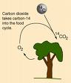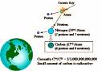
Rachel: Okay, Ross, I'm really trying to tell you something here.
Ross: Yeah.
Rachel: Okay.
Ross: Go ahead.
Rachel: Umm, okay, I think I'm-I'm just gonna-just gonna say it. Just gonna say it. Uhh, (pause) I'm still in love with you Ross.
(Ross is stunned.)
Ross: Wow. Umm… Huh… I'm-I'm not sure what to do with that right now.
(Rachel starts laughing hysterically.)
hysterically adv.歇斯底里地
Ross: What? What? Was that a joke? 'Cause it's mean.
mean adj.低劣的 卑劣的
Rachel: (Laughing) I'm so dead serious. I'm totally serious.
dead <口>绝对 极为
Ross: Why are you laughing?
Rachel: Because (laughs), because, I just heard it. I heard it, and it's ridiculous! I mean, you're married. You're-you're married and it's just ridiculous, and it's like, it's like when said it, I sort of like, I floated up out of my body, y'know? And, and-and then I heard myself say it and then the floating Rachel (laughs) was like, "You are such an idiot!"
float up out of one's body 灵魂出壳
Ross: Well, well I am married. Even though I haven't spoken to my wife since the wedding.
Rachel: (laughs) I'm sorry, that's not funny.
Ross: Actually, it kinda is. My wife won't return my calls. I don't know where my wife is. (Laughs) "Hey Ross, where's the Mrs.?" Don't know!
Rachel: Oh God, ohh, okay, y'know what, do you think ah, do you think that you just forget that I told you this?
Ross: Well, I kinda have to. I mean, because the thing is…
Rachel: The thing is y'know, that you're married to Emily.
Ross: That is what the thing is.
Rachel: Ross, things aren't gonna be weird between us, right? I mean was that just the stupidest thing, me telling you that?
Ross: No. No. No, I'm-I'm glad you did. Look, if nothing else, it's-it's always great when someone tells you they love you.
Rachel: That's what I said! Ross, Thank you for being so nice. (They hug.)
Ross: No thank you for… Thank you.
Rachel: Oh, God. I'm just glad I didn't give you the cassette I made of all of our songs.
cassette n. 盒式磁带
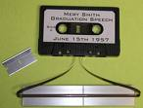
Ross: What songs?
Rachel: Oh, you know: 'With or Without You'
With or Without You: is the lead single from U2's 1987 album, The Joshua Tree. It has since become one of the band's most popular songs. Released as a single in March 1987, it became the group's first American #1 hit, spending three weeks at the top; it also reached #4 in the UK.
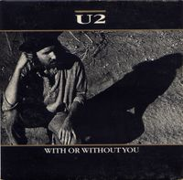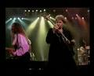
Ross: Oh, yeah.
Rachel: 'Everybody Hurts.'
Everybody Hurts：For the album by Air, see Everybody Hertz."Everybody Hurts" is a song by R.E.M., originally released on the band's 1992 album Automatic for the People and was also released as a single in 1993. It peaked at #29 on the Billboard(n.美国公告牌杂志) Hot 100 and #7 on the UK Singles Charts.
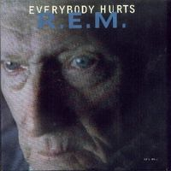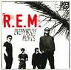
Ross: Oh, yeah.
Rachel: 'Rhiannon.'
Rhiannon：In the Mabinogion of Welsh mythology Rhiannon is the horse goddess, equivalent to Epona from Celtic mythology. Rhiannon was a daughter of Hefeydd the Old. She was married to Pwyll and, later, Manawydan.

Ross: Why 'Rhiannon'?
Rachel: Come on, you remember! In the Iiving room? On Monica's laundry?
Ross: Not me.
Rachel: Really?!
[Scene: Monica and Rachel's, the gang is about ready to leave for Atlantic City.]
Monica: So, what happened?
Rachel: Well, it was really hard but I'm gIad I did it.
Monica: So was I right or wrong?
Rachel: Oh, come on, honey, does it really matter?
Monica: No.
Rachel: Right
Monica: Yes. I need it for my scorebook. Diary.
scorebook n.得分记录簿
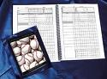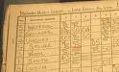
Ross: Okay, let's go!
Chandler: Atlantic City!
Phoebe: Atlantic City, baby! Let's roll some bones! Hey Joey, high-five for rolling bones!
bone <口>骰子/roll some bones<口>赌几把
(They high-five and howl, but Phoebe suddenly stops and the guys gasp and retreat in shock.)
howl v.嚎叫
Joey: Uh, Pheebs, you're leaking?
leak <俚>撒尿
Monica: Oh my God! Your water broke你羊水破了!
The Guys: Ohh!
Phoebe: All right. Well, don't worry, I call shotgun! (She starts out the door.)
shotgun <俚>The front right seat of a car <词源>Comes from the Americans fascination(n.迷恋) with the Old West when the person sitting next to the coach driver carried a shotgun to fend off robbers or Indians

Cobain <俚> The right rear seat of a car (Seat in the car that is behind shotgun). Since Cobain was beind a shotgun when he died, it got this name.
All: Whoa-whoa-whoa-whoa! Wait-wait!
Chandler: Pheebs! We have to take you to the hospital now!
Phoebe: Okay. Well, there's probably one on the way to Atlantic City.
Ross: Pheebs, Pheebs, the babies are coming now.
Rachel: High-five, the babies are coming! (They all high-five.)
Phoebe: Wait, wait, remember when my water broke? (They all high-five again.)
Ending Credits
[Scene: The hallway between the apartments, they are taking Phoebe to the hospital but Chandler and Monica hold back.]
hold back v.断后 留在众人之后
Monica: I can't believe Phoebe's gonna have her babies!
Chandler: I know, it's beautiful. Amazing.
(They both kiss.)
Chandler: Y'know what else I can't believe? I had to kiss Phoebe and Rachel every time I left a room, I mean it's too bad they didn't see us having sex.
Monica: Do you know anything about women?
Chandler: No.
Monica: That's all right.
Chandler: Okay. (They kiss again.)
End

